Jennifer Stegina

20 September 2019

CIS 250

**Unit 4 Graded Exercise 3**

The following questions come from the Check your understanding examples of each section of chapter 14 in your textbook.

After you are finished, please submit the Microsoft Word file that contains screenshots of the SQL script and the resulting tables. Your document should be named **U4_GradedExercise3_Lastname.docx**.

(14-3) Question 1:

The following *select* statement shows all the employees who are in each department. First run this code as it is—as an inner join. Then change it to a left outer join. What is the difference in the result tables?

*select a.department_name,*

*b.first_name,*

*b.last_name*

*from l_departments a,*

*l_employees b*

*where a.dept_code = b.dept_code;*

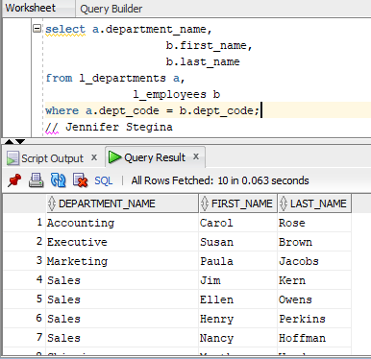

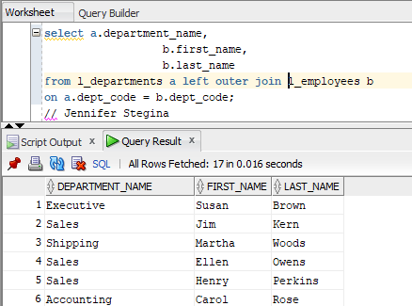

The left outer join keeps all the rows of the first table, but only has the rows from the second table that have a match from the first table’s rows.

(14-4) Question 2:

This is a modification of the exercise in **section 14-3**. The only thing that has been changed is the order of the tables in the *from* clause. First run this code as it is—as an inner join. Then change this select statement to a right outer join. What is the difference in the result tables?

*select a.department_name,*

*b.first_name,*

*b.last_name*

*from l_employees b,*

*l_departments a*

*where a.dept_code = b.dept_code;*

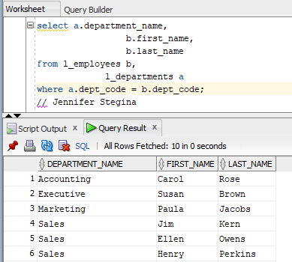

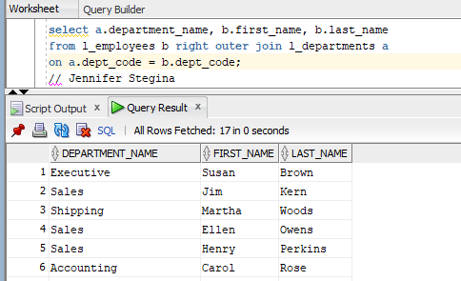

The right outer join kept all of the rows from the second table but has only the rows from the first table that match a row with the second table.

(14-5) Question 3:

This is a modification of the exercise in **section 14-3**. The only thing that has changed is that table *sec1405_employees* replaces table *l_employees*. The new table contains one new employee who has not been assigned to any department yet. First run this code as it is—as an inner join. Then change this *select* statement to a full outer join. What is the difference in the result tables?

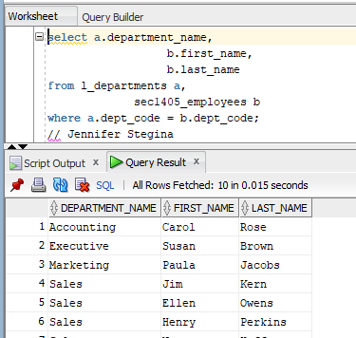

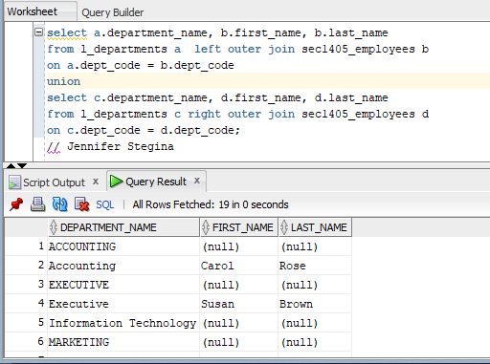

The full outer join added back all of the rows that were dropped from both tables by the inner join.

(14-7) Question 4:

The table *sec1407_departments* has the same format as the *l_departments* table. Write a *select* statement that shows the union of the two tables.

